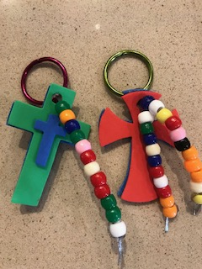
How to Make a Backpack Cross Key Chain

Here is what to do:

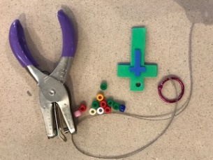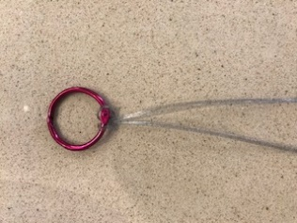
- Take out all key chain pieces out of the bag. Using a hole puncher, punch a hole in the top of the cross.
- Fold the lanyard in half and lay it against the book clip. Bring up ends of the lanyard and slip through the lanyard fold. Pull tight.

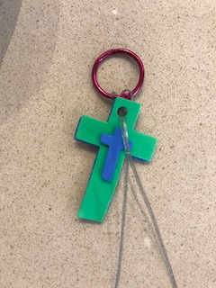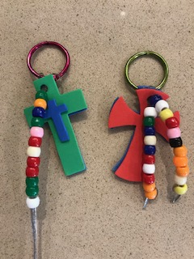
3. Add cross and beads to lanyard.

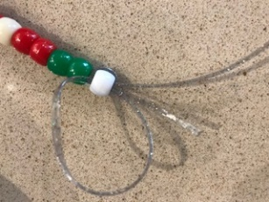
5. Open up clip and add to your back pack!
4. Once you put the last bead on the lanyard, you will need to tie it off. An easy way to do this is to pull the end of the lanyard through the last bead one more time. Pull tightly and trim off

