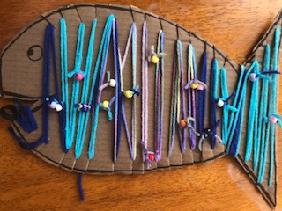
The Fish With the
Coin in its mouth

Craft Instructions
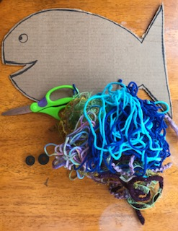

Materials needed: cardboard or poster board, a sharpie, string, 2 pieces for coins such as buttons, 0-rings, or washers, and bling (beads, bells, extra yarn, etc).

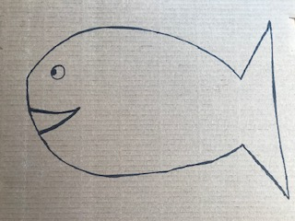
Step 1: Draw a fish on the cardboard or poster board with a sharpie. Cut it out including the mouth.

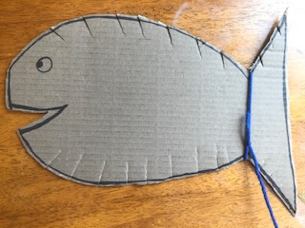
Step 2: Along the edge of the fish, cut slits about ½ inch apart.

Step 3: Use string to yarn bomb the fish. Starting at the tail, wrap the string around the fish into the slits.

Step 4: At the mouth before you tie off the string, add the two pieces [washers, buttons, or 0-rings] to represent the coins in the fish’s mouth!

Step 5: Add some bling! Hang the fish were you will see it to remind you that Jesus works miracles every day.

